**14/09/2021 CD SPOT 2 2019103573**

**EXCERSISE**

**1.To count and print words that has atleast two vowels.**

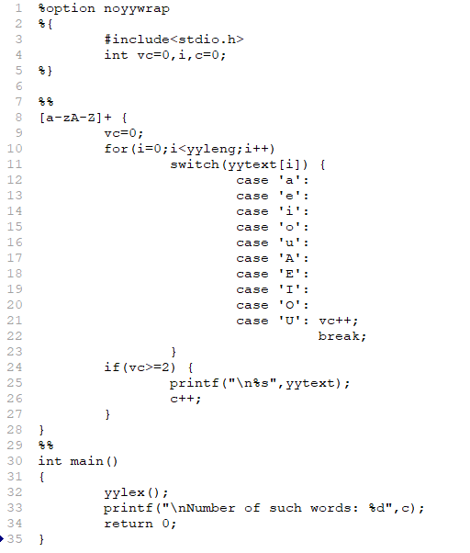**Code :**

**Output :**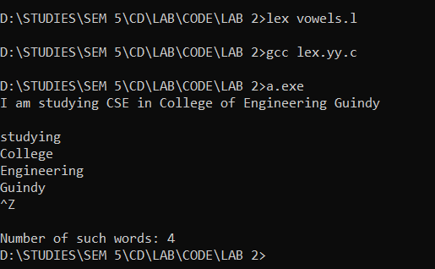



**2.Identify the keywords and convert it into Uppercase.**

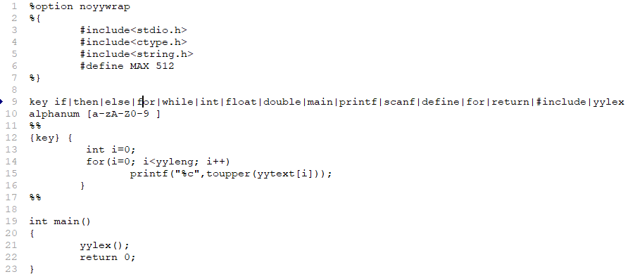**Code :**

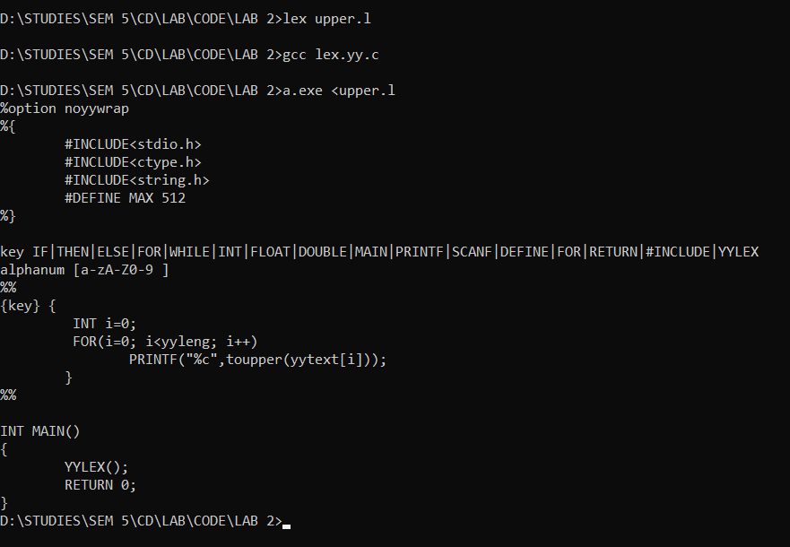**Output :**

**3.To count and print words that are in mixed case.**

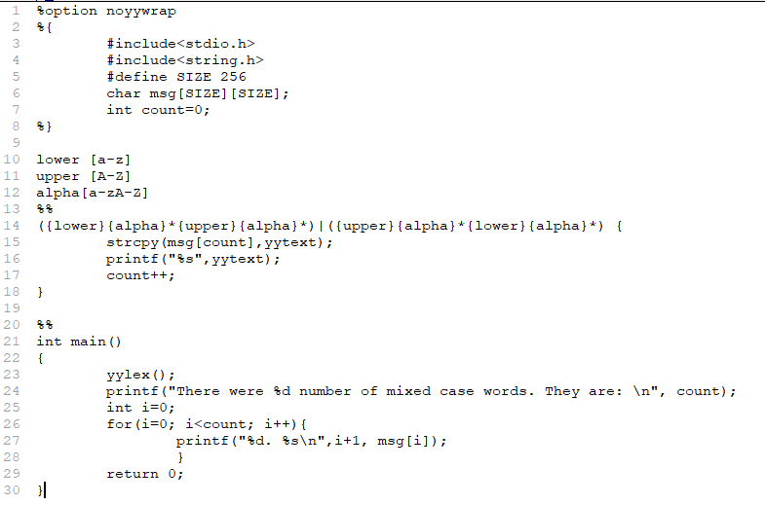**Code :**

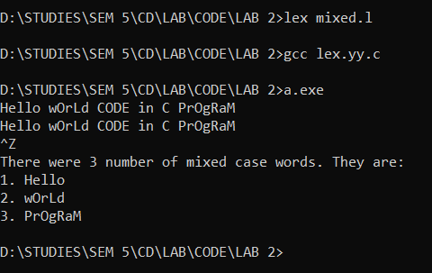**Output :**

